Project Final Copy
Uploading a Document in Turnitin and Reviewing the Similarity Score
Description
Turnitin is an internet-based service that helps to detect similarity on documents. To upload a document in Turnitin and review the similarity score, a student will login to their blackboard account at no additional cost. You can create a Turnitin Assignment directly in your Blackboard Classroom.
Tools Needed
- The document to be reviewed
- Blackboard login information
- Internet browser installed in a laptop or desktop.
- Fast internet connection.
The following are the set of instructions to successfully upload a document.
- Find which lesson within your course you are wanting to deploy your assignment.
- Select Turnitin Assignment from the Assessments menu (note that Turnitin Assignment must be made available in the Customization/Tool Availability area for this option to be visible under Assessments).
- If this is your first time using Turnitin, you may be asked to accept a user agreement.
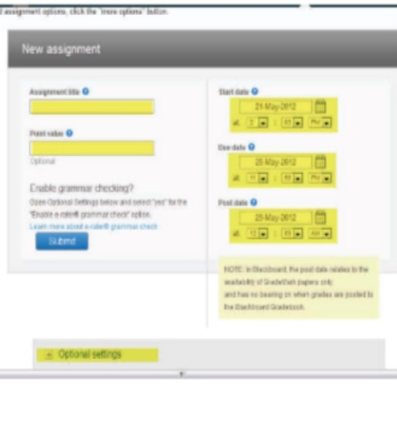
- An embedded “New Assignment” screen will show up within your Blackboard classroom. On this page, you will fill in the “New assignment” information; Assignment Title, Start/Due/Post date and an optional Point value box.
- Once the assignment details are completed, hit the Submit button to create the Turnitin assignment in your Blackboard classroom.
The following are the set of instructions to successfully view grading submissions.
- Note the “Needs Grading” exclamation point in the Grade Center.
- Click the link that relates to your submission and click on an attempt to view it.
- The Modify Grade screen will present several options.
- You can view a submitted file by selecting the User’s Paper icon. To run a plagiarism report on the submitted work, select the Originality Report icon. Feedback can be entered here.
- A new window will open with the results of the report. Here you can view similarities between the submitted paper and other sources and view those sources on the Internet.
Online Support:
Instructor and student training materials are available at Turnitin’s link below.
Welcome to help.turnitin.com, the new home for guides.

